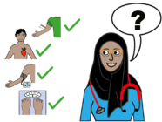
About this survey

You recently had a combined health check.

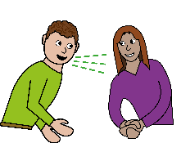
We would like to know what you thought of it.


Your feedback will help us understand what is working well and what we could do better.



Who we are
We are the Strategy Unit. We are part of the NHS.

We help the NHS learn from what it does and find ways to improve.

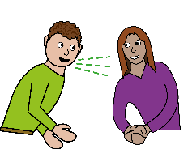
What we are asking you to do
We would like to talk to you about your combined health check.
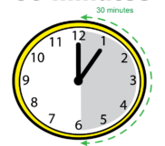
The conversation will be short. It will take 30 minutes.


We will ask you about:

- What you thought about the combined health check
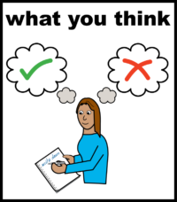
- How it compared to other health checks you have had before

- How we could make the health check better

How the conversation will happen
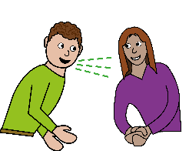
If you want to take part, someone from the Strategy Unit evaluation team will contact you.

We will use the contact details you gave us in the feedback survey.

We will arrange a time that works for you.
You can choose how we talk:

- By telephone
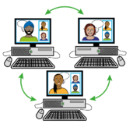
- By video call using Microsoft Teams

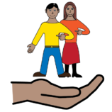
You can bring someone with you if you want. This could be a friend, family member or support worker.


What we will do with the information you share
We will use what you tell us to write a report about the service.



We may include some of your words in the report.

We will not use your name. We will not include anything that could identify you.
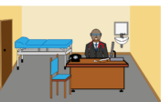

We will share the report with NHS England and the GP practices offering the combined health check.

Keeping your information private
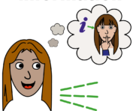
What you tell us will stay private.

There is one exception. If we are worried about your safety, or someone else's safety, we may need to tell your GP practice what you said.

Recording the conversation

We will record the conversation. This helps us write up what you have told us.


The evaluator will ask if you are happy to be recorded. If you are not happy, we will take notes instead.

Only the evaluation team will hear the recording.

How we store your information
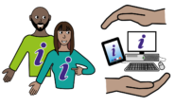
We will keep your information safe. We follow the General Data Protection Regulations (GDPR).
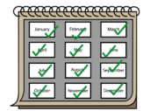

We will keep your information for 12 months. After that, we will delete it.

Your rights
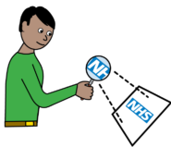
NHS England is the data controller for this evaluation. The Strategy Unit is working on their behalf.


You have rights about how we use your data. To find out more, visit the NHS England privacy policy page:
NHS England privacy policy: www.england.nhs.uk/privacy-policy

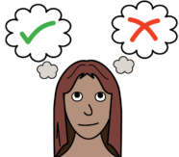
Do I have to take part?

No. Taking part is your choice.

If you choose not to take part, this will not affect:

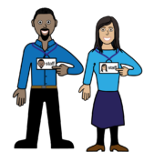
- the care you get from your GP practice

- any other care, support or treatment you receive

What if I change my mind?
You can stop at any time. You do not need to give a reason.
If you do take part, you can:

- skip any questions you do not want to answer
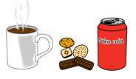
- take a break whenever you need one

Please note: If you change your mind after sharing your views, we may not be able to remove what you said from our report. This is because the evaluation team may have already started looking at the results.


Will I get anything for taking part?
We are not able to speak to everyone. But if we do speak to you, we will give you a £20 gift card to thank you for your time.

You can spend this card at many shops.

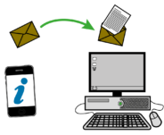
Who should I contact if I have questions?
Contact Bethany Mitchell if you have any questions about this evaluation.
Email: bethany.mitchell21@nhs.net
Bethany is part of the Strategy Unit team running this evaluation.

Part B: Agreeing to take part
Before we start, we need to make sure you understand what taking part involves and that you are happy to continue.
Our researcher will go through the following points with you.
Understanding this information
Have you read this information sheet? Or has someone read it out to you? This sheet explains how we will use and protect any information you share with us.
Asking questions
Have you had the chance to ask any questions you might have?
Recording the conversation
Do you agree to us recording this conversation? We will use the recording to help us write up what we learn. If we quote anything you say, we will not include your name or any details that could identify you.
If you do not want us to record the conversation, we can take detailed written notes instead. If you do not want us to make any record at all, we will not be able to continue with the conversation.
Changing your mind
You can stop taking part at any time. You do not need to give a reason. When we have collected and analysed your comments, we will not be able to remove them.

